One day training programme on “Content Management System” organised at ICAR-ATARI, Jodhpur
Jodhpur
16th December, 2025

One day training programme on “Content Management System” for website development and updation has been organised today at ICAR-ATARI, Jodhpur.
Dr. P. P. Rohilla, PS (LPM) & Director I/c emphasized upon contents of website of KVKs which is the face value of each KVK along with ICAR and very much essential for transfer of technology in the present digital era.
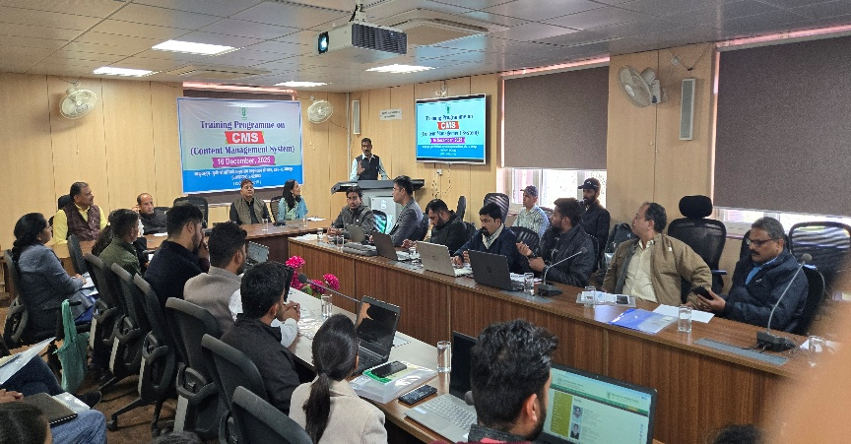
Dr. M. S. Meena, PS (AE) highlighted the importance of the training and urged upon regular and instant updation of websites with proper linking policy. He also emphasized upon linking websites of KVKs with other stakeholders’ websites like ICAR Institutes, host organisations, etc. by which farmers can get most of the information like technologies, schemes being implemented, etc. at their fingertips.
Dr. Ganga Devi, Senior Scientist (Ag. Eco.) and training coordinator welcomed the participants and stressed upon the art of development of proper content of the website.
In the training programme 48 KVKs of Rajasthan and Haryana took part and experts from M/s. OmegaTelesolutions, Nagpur imparted hands on training on login to server and content development and updation.
Source : ICAR-Agricultural Technology Application Research Institute, Zone-II, Jodhpur

