AGRICULTURAL TECHNOLOGY APPLICATION RESEARCH INSTITUTE
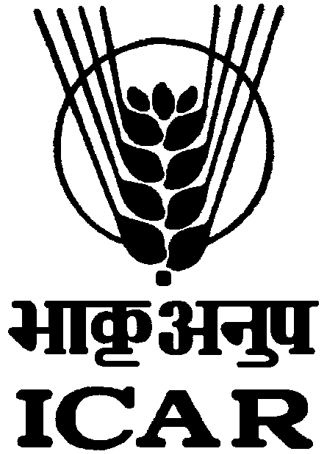

INDIAN COUNCIL OF AGRICULTURAL RESEARCH

CAZRI Campus, JODHPUR (RAJ.) 342 005
F.No. : ZPD/-VI/Rectt./Jr. Clerk/2011 Dated 27.07.2017.
Notice

It is inform to all the applicants, who have already submitted their applications for the post of LDC in reference to advertisement No. 01/2016, the said common examination through computer based on-line mode shall be conducted on 10/09/2017 (Sunday) at various centres across the country. For this purpose, all the concerned applicants are requested to visit the website of ASRB/ICAR viz. www.asrb.org.in / www.icar.org.in and submit their particulars in the application format available online on the given link during the period from 28/07/2017 (9.00 (AM) to 17/08/2017 (5.00 PM). No fresh applications by new candidates will not be entertained under any circumstances.

Detailed Notice is available on the Institute’s website : www.atarijodhpur.res.in

DIRECTOR

